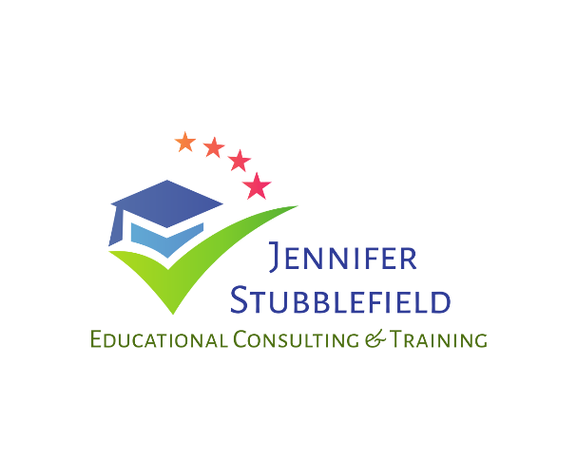
How May I Assist Your Business?
I look forward to the possibility of working with you!
- Keynote Speaker
  - $600 for keynote speaker, add $100 for up to two breakout sessions
  - Topics vary and can be customized
  - All conference expenses covered, including hotel and transportation
  - Reduced rates for travel if less than three hours from my home
- Breakout Sessions/Workshops
  - $350 flat fee, add $100 for up to three breakout sessions on same day
  - All conference expenses covered, including hotel and transportation
- Microsoft Office Corporate Training
  - $100 per hour
  - $40 per hour for prep time
  - Word, Excel, and PowerPoint; Specialize in MOS Certification test prep
  - All travel expenses covered, including hotel and transportation
- Business Communication/Soft Skills/Etiquette Training
  - $100 per hour
  - $40 per hour for prep time
  - All travel expenses covered, including hotel and transportation

